Giant Garden Games Page
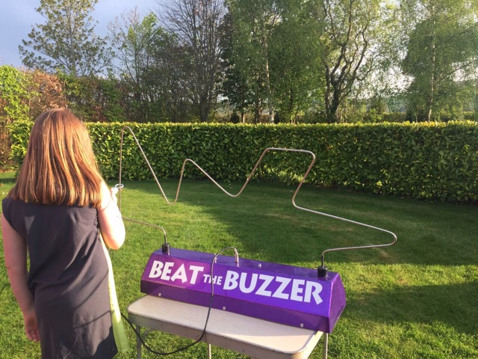
Beat the Buzzer Game – add on to your party or event from € 50
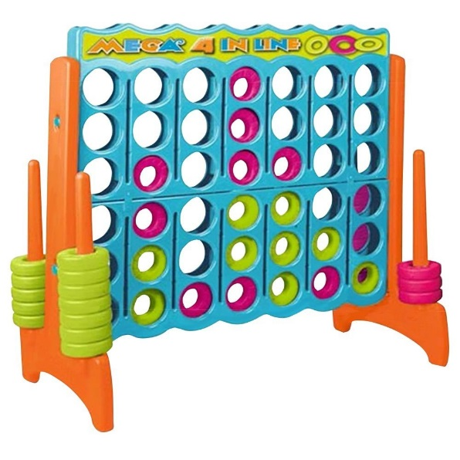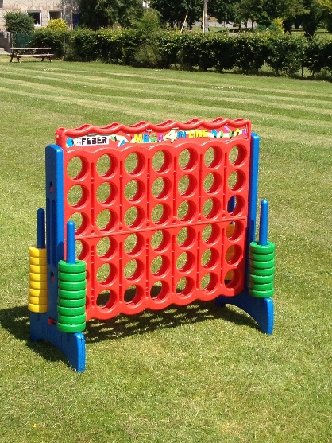
Giant Connect 4 – add to your party or event from € 30

Giant Garden Games

Giant Chess – Add on to your party/event from € 40

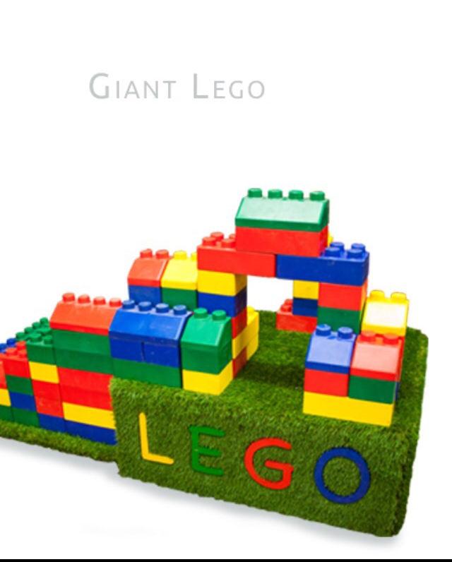
Giant Lego add to your party or event from € 30

Need to get Picture of Giant Jenga

Add Giant Jenga to your party from € 30

